Press release – Photos prohibited in the sights of Sedlec

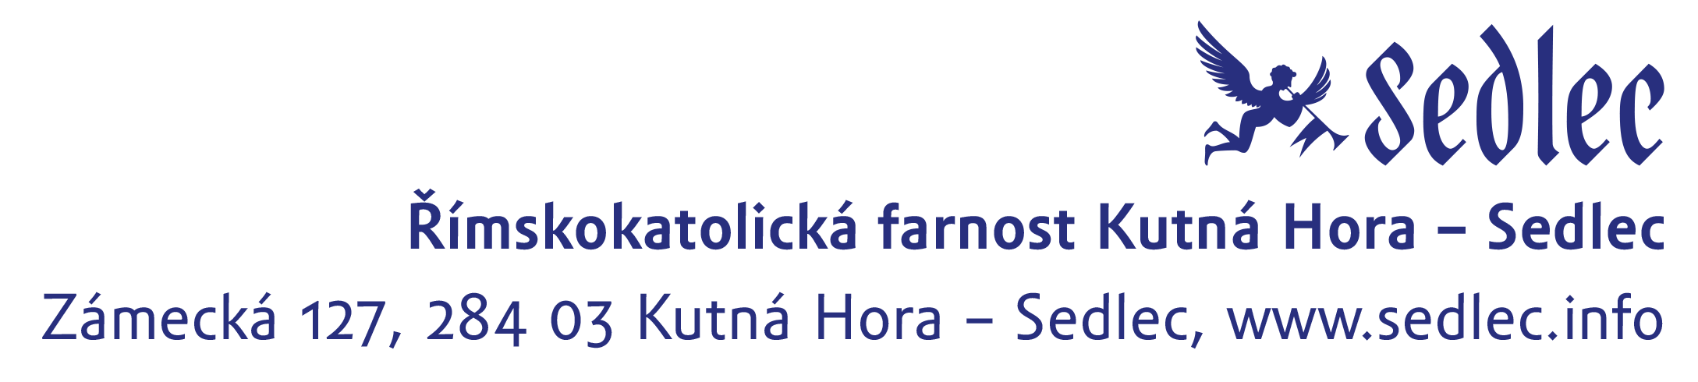
From 1st of January 2020, there will be a blanket ban on any photography in the All Saints Church with the Ossuary and the nearby Cathedral of the Assumption of Our Lady and Saint John the Baptist in Kutná Hora - Sedlec. The Roman Catholic Parish of Kutná Hora - Sedlec decided to act this way in order to preserve the piety of both sights.

The All Saint Church is annually visited by up to half a million visitors and not all of them understand the significance and historical context of this globally unique monument. In such a sacred resting place of 60 thousand deceased, visitors have taken derogatory photos, inappropriate selfies and have even manipulated bones in order to create an interesting photo. This behaviour of some visitors as well as the publication of these inappropriate photos and videos on various social networking sites has had a negative impact on tourism.

The parish has been trying for a long period of time to respectfully restore the piety of the Church of All Saints to its former peace and tranquillity without restricting the entrance to the Ossuary. In conjunction with this, the overall renewal of the Ossuary, whose only investor is the parish, continues to depend on the income from tourism.
This year, in order to minimize the negative impact of tourism, the parish moved the location of the ticket office for both Sedlec sights to the premises of the newly built cash desks in the Information centre. This move is to relieve the nearby cemetery from the endless queues. In the recent years, it has also implemented a security guard, whose role is to supervise the behaviour of tourists not only in the area of the lower chapel but also in the adjacent cemetery.
"We believe that our visitors will respect this decision and at the same time will understand the reasons that led us up to this step," stated Radka Krejčí, the director of the parish organizational unit.

