Sedlec monuments in Kutná Hora are closed until further notice

In connection with the declaration of the coronavirus pandemic, both Sedlec monuments – the Cemetery Church of All Saints with Ossuary and the Cathedral of the Assumption of Our Lady are closed until further notice. Other services, such as the Information Centre - Sedlec and Public toilets in Zámecká Street are also closed until further notice.

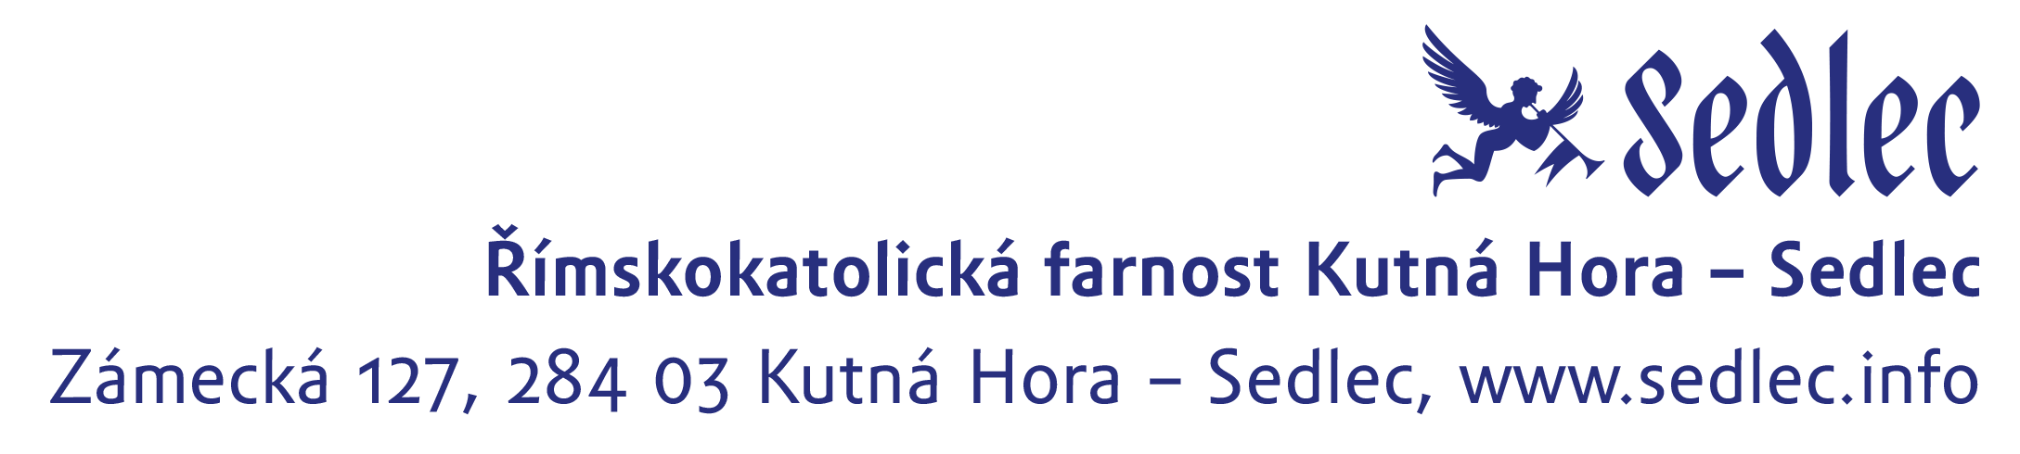
All new information will be published on the official website www.sedlec.info and on the official FB profile - Information Centre Kutná Hora – Sedlec. More information can be also obtained at telephone number 326 551 049 during the closures of both monuments.

